**SPRING-DATA-JPA-HANDSON**

**OUTPUTS**

**HANDSON-1**

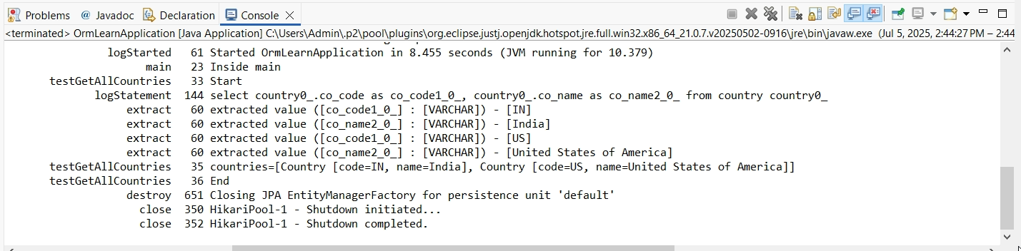

**HANDSON-2**

